English 12 Regular
Course Expectations
Mrs. Rose

E-mail: rose@strongnet.org
Homework Hotline/Voicemail: 440-268-5575 (Program this number into your cell phone – I update weekly)
Free Periods: 5, 6 (in Media Center), 7
Office: Mezzanine Room: 114
Website: http://rosesonlineclassroom.weebly.com

Dear Parents and Students,

Welcome to English 12! I look forward to a rewarding year in a class of unique individuals. I ask that students and guardians read the following information in preparation for this course. Please keep in mind that I believe in a classroom that models the “real world,” and I expect you to act like a mature young adult every day.

Course Description:
English 12 Regular Students study the development of British literature and representative writers/selections of each of these seven periods: Anglo-Saxon, Middle Ages, Renaissance, Restoration/Enlightenment, Romantic, Victorian, and the Twentieth Century. The student will learn how the literature reflects English history and how, in some cases, the literature has helped to create the history and the language.

Units of Study:
Although we have a variety of skills and concepts to master, the following list should provide a general idea of what we will be studying throughout the year. It is not meant to include everything that we will be studying, and will be subject to change. Schedules will be provided for units.

Specific Units of Study:
- The Anglo-Saxons 449-1066 (Beowulf, “The Seafarer,” Anglo-Saxon Riddles)
- The Middle Ages 1066-1485 (The Canterbury Tales, Arthurian Legend)
- The Renaissance 1484-1660 (Macbeth, Sonnets, Ballads)
- The Restoration and the Eighteenth Century 1660-1800 (Metaphysical Poetry, “A Modest Proposal”)
- The Romantic Period 1798-1832 (Romantic Poetry)
- The Victorian Period 1832 -1901
- The Twentieth Century/Modern – 1901-Present

Textbook: Prentice Hall Literature: The British Tradition

Independent Novels and Literature Circles
- Students will receive a novel during second semester
- Students will be asked to acquire novels during first semester (Frankenstein. Dr. Jekyll and Mr. Hyde, Dracula, or The Island of Dr. Moreau)

Essays
- This I Believe Essay
- College Essay

The Research Paper
- Students will be required to compose an extensive research paper that demonstrates the skills learned throughout high school

Creative Writing Assignments

Academic Expectations:

Students are responsible for completing assignments on time and in their entirety by the assigned due date. Late work will not be accepted unless there is an excused absence, or prior arrangements have been made with the instructor. Typical academic expectations include:
Homework - daily and long term assignments
Class Participation – essential to class discussion and ensuring comprehension of the material
Writing – essays and journals
Research – extensive research paper during third quarter
In class assignments and group work
Quizzes/Tests/Semester Exam

- Projects / Presentations: Expect to complete several projects and oral presentations over the course of the school year. Some projects / presentations may be individually completed, while others will require group work and effort.
  - I will always provide a rubric and clear directions.
  - I will always provide a due date after discussing the directions.
- Homework: Homework will be given at least 4 times a week.
- Late Work: I do not accept late assignments. If you are absent, then you have one day to complete the necessary assignments.
- Absences: When absent, take the following steps:
  - Check the homework hotline (this should be programmed in your cell phone)
  - Check the schedules given for units
  - Check my website
  - Ask a reliable friend
  - Ask Mrs. Rose BEFORE or AFTER class (never during class)
- MISSING QUIZ/TEST: see me upon your return to schedule an appointment to make up your work. Failure to show up to this appointment will result in a ZERO on the missed assignment. The quiz/test must be completed within 3-5 days of your absence.
- OTHER ASSIGNMENTS: YOU are fully responsible for all written and oral assignments, instructions, and information presented in class, whether you are present or not.
ATTENDANCE IS NECESSARY AND REQUIRED TO PASS THIS CLASS
- Participation: A portion of your grade will consist of class participation. The student is required to PAY ATTENTION to the teacher and other classmates. There will be a grade on class participation due to the amount of class discussion in this course. Listening and responding are essential behaviors in receiving a passing grade.
Attendance is crucial in receiving full credit for class participation. I understand that true emergencies occur and student must be EXCUSED from school. Students are allowed three EXCUSED absences without penalty during a quarter. Students must make up the work on these EXCUSED absent days.

If students are attentive during class and complete assignments on time, then they will receive 100/100 points on “Class Participation.” However, absences can alter grades.
Absence Key (Quarterly)
0-3 absences = 100/100 points
4-5 absences = 80/100 points
6-7 absences = 50/100 points
8-9 absences = 30/100 points
10 or more absences = 0/100 points
**Planned absences, vacation, court dates, college visitations, etc. must be handled in accordance with school policy. You must inform the teacher of your planned absence at least two school days in advance. If you have a planned absence during which a longer term assignment is due, the assignment is due before you leave. Bloodmobile appointments do not excuse you from work due that day. While I appreciate your social commitment and willingness to help the greater community, it does not exempt you from your scholastic commitments.
- Cheating / Plagiarism: Academic integrity is essential. Students who deliberately use the work of others without proper referencing or who fail to give credit to others will be severely penalized at my discretion. At the VERY LEAST, plagiarism will result in failure of the assignment. Any student found guilty of cheating will receive a zero on that assignment or test. Cheating constitutes looking at, or copying from another student’s paper, talking during test time, or “sharing” homework. If your cell phone is out during a test or quiz, then I will assume you are cheating. Additionally, plagiarism on papers will not be tolerated. It’s cheating and it’s illegal. When in doubt…always document your source. Students will submit all formal papers to turnitin.com. Students find it quite easy to plagiarize to save time, but it is quite easy for the teacher to discover in a short amount of time.
Turnitin.com information: English 12 Second Period ID: 5382214 PW: Rose
English 12 Fourth Period ID: 5382232 PW: Rose
English 12 Eighth Period ID: 5382237 PW: Rose

Behavioral Expectations and Consequences:
- Respect ALL individuals within the school at ALL times.
- Be prepared! ALL students must bring required materials to class ON TIME.
- Assignments are to be completed on time. Late assignments WILL NOT be accepted.
- Pay attention in class. Do NOT sleep, listen to headphones, play with your cell phone, or attempt to complete other assignments during the period.
  - I will send your administrator a referral if you listen to your MP3 player.
  - I will send your administrator a referral if you use your cell phone! Please be aware that I find the behavior of texting while someone is verbally communicating with you incredibly rude. When you come in for help, I can promise you that I will not text while you are communicating with me. Let’s show mutual respect for what we have to say.
  - I will take any other devices that cause disruption to my classroom.
- The STUDENT is responsible for completing all absent or missing work. These assignments should be addressed before or after class- NOT during the period.
- NEVER make another individual uncomfortable. Racist or sexist comments will NOT be tolerated.
- All the rules within the “Student Code of Conduct” section of the handbook apply within the classroom at ALL times.
- ALWAYS contact the teacher whenever there is a problem.
Discipline:
  - First and Second Offense: Verbal warning
  - Third offense: Conference with Mrs. Rose
  - Fourth Offense: Phone call home and referral to administration
- Serious offenses, such as intolerant and disrespectful behavior will result in an immediate escort to the principal’s office as well as a phone call and meeting with parents

Grading Procedures:
We will follow the grading scale designated by Strongsville High School. Please see your student planner for a description of our grading scale.

Be aware that your grade will be based upon the completion of homework, writing, tests, quizzes, participation, and note checks.

Required Materials:
These materials are due by ________________________________!
- Binder (at least 2 inch with pockets) - This binder is NOT to be shared with any other subjects. The student is to write “English” and his/her name on the cover of this binder. I will check and grade notes taken in class- there will NOT be a warning as to when I check binders—be prepared!
- Page Protectors- You will need at least 10 page protectors for the use of holding flashcards and other items that cannot be hole punched.
- Notebook Paper- Please put a full pack of notebook paper in your binder.
- Packet of Section Dividers- These will be used to organize your binder. Divide these into:
  - The Anglo-Saxons 449-1066
  - The Middle Ages 1066-1485
  - The Renaissance 1484-1660
  - The Restoration and the Eighteenth Century 1660-1800
  - The Romantic Period 1798-1832
  - The Victorian Period 1832 -1901
  - The Twentieth Century/Modern – 1901-Present
  - Writing
- Highlighters- I will constantly ask the students to highlight important information. Hopefully, this will promote reading skills.
- Pens- I prefer you write in blue or black pen. Do not use neon colors.
- Pencil- We will only use pencils occasionally, but they are necessary.
- Flash Drive
- Box of Tissues or Hand Sanitizer
- Student Planner and I.D. tag.
  - If you do not have your planner, then you will not receive any passes to leave my class.
  - If you do not have your I.D., then you will not be able to access materials from the Media Center

Research Paper:
Students will complete a research paper after first quarter.
- the research paper is a significant portion of the quarter grade
- students must plan computer accessibility during this time

Final Note:
As a Strongsville student, you should expect a challenging course this year. However, English class can also be fun (even while we are learning)!
The syllabus is a contract between the STUDENT and TEACHER. You are responsible to become familiar with the rules and regulations of English class. If you are uncertain about any of this information, then ask questions!
Mrs. Rose’s Schedule 2011-2012
1st period – 814
2nd period – 814
3rd period – 814
4th period – 814
5th period – LUNCH IN MEZZANINE
6th period – DUTY – MEDIA CENTER
7th period – PLANNING IN MEZZANINE
8th period – 814

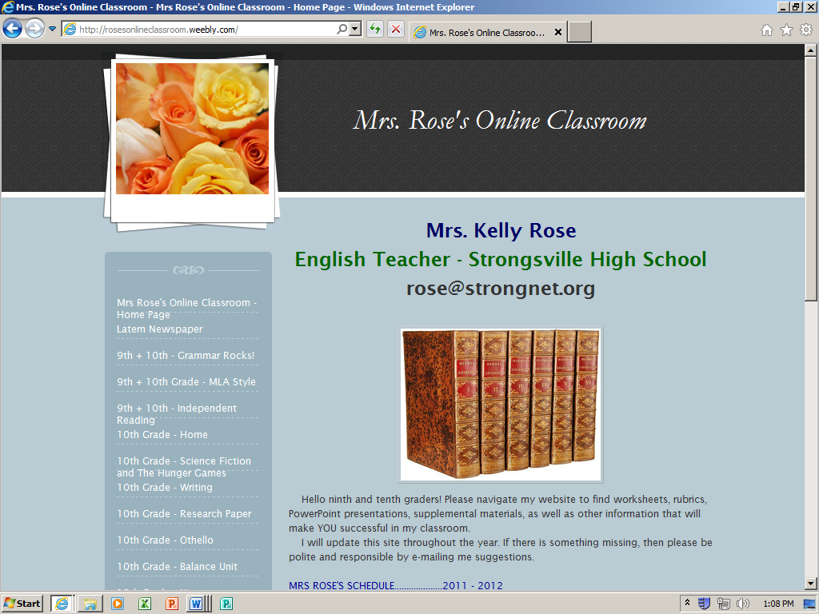

English 12 Regular Contract
Teacher: Mrs. Rose
Office: Mezzanine
Rose@strongnet.org
http://rosesonlineclassroom.weebly.com

I have read the course expectations. I understand all of the information and agree to abide by the rules and regulations presented throughout this contract.

_______________________________ _________________________________
(student signature) (student name- please print)

Date: ________________________________

Parents/Guardians: Please read the course expectations with your child. This page is due on ________________________ (the same day your child is to have the necessary supplies for this course).

_______________________________ ___________________________________
(parent/guardian signature) (parent/guardian name- please print)

Phone Number: ______________________________________________________________________

E-mail Address: ______________________________________________________________________

Date: _______________________________

Please write any additional comments/questions in the space below.
Suggestions: IEPs, Disabilities, Special Seating Accommodations

